XVII Congreso Galego de Estatística e Investigación de Operacións
Ourense, 23-25 de outubro de 2025

TITLE

Author 1¹, Author 2² e Author 3³

¹ Author 1's Affiliation
² Author 2's Affiliation
³ Author 3's Affiliation

ABSTRACT

Include here your abstract.

Keywords: Include here your keywords (six as maximum).

1. INTRODUCTION

Include here your introduction.

2. TITLE OF THE SECTION

Include here the second section. The format of the table has to be the following. Author can insert lines between rows and/or columns..

1 | 2 | 3 | 4
5 | 6 | 7 | 8
9 | 10 | 11 | 12
13 | 14 | 15 | 16

Table 1: Include here comments on the table.

If a figure is required, the format of Figure 1 has to be respected..

3. CONCLUSIONS

Include here the conclusions. This section is optional.

REFERENCES

Dantzig, G. B. (1940) On the non-existence of “Student's” hypothesis having power functions independent of σ. Annals of Mathematical Statistics, 11, 186-192.
Efron, B. and Tibshirani, R. (1994) An introduction to the Bootstrap. Chapman & Hall.
Nash, J. (1950) Equilibrium points in n-person games. Proceedings of the National Academy of the USA, 36, 48-49.

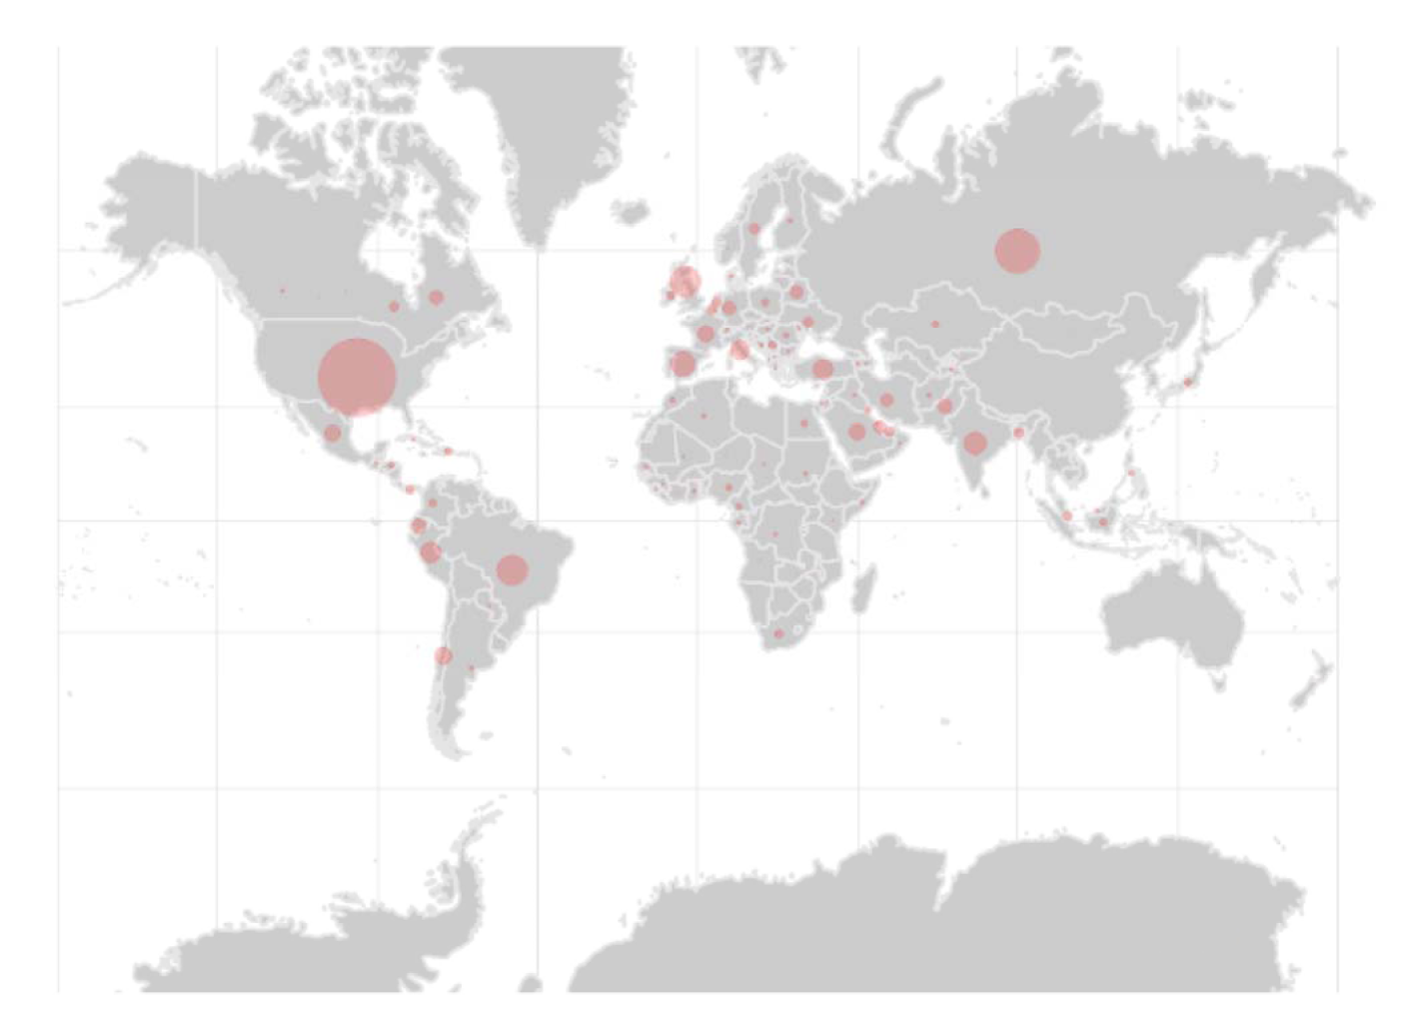
Figure 1: Include here comments on the figure.

